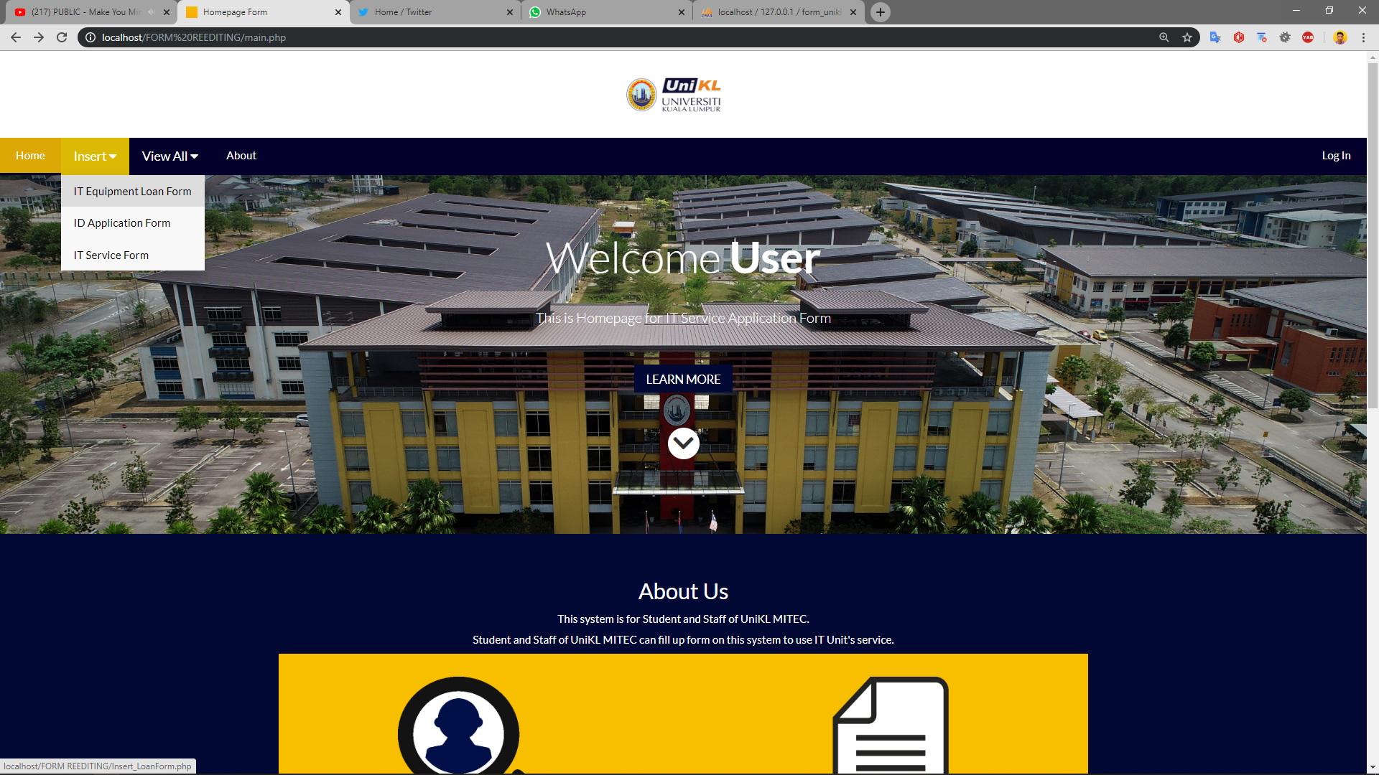

**3**

**2**

**1**

1. If user want to use an IT appliances from IT Unit, they need to fill up IT Equipment Loan Form.

2. If user want to make an ID, they need to fill up ID Application Form.

3. If user want to ask for a service from IT Unit, they need to fill up IT Service Form.

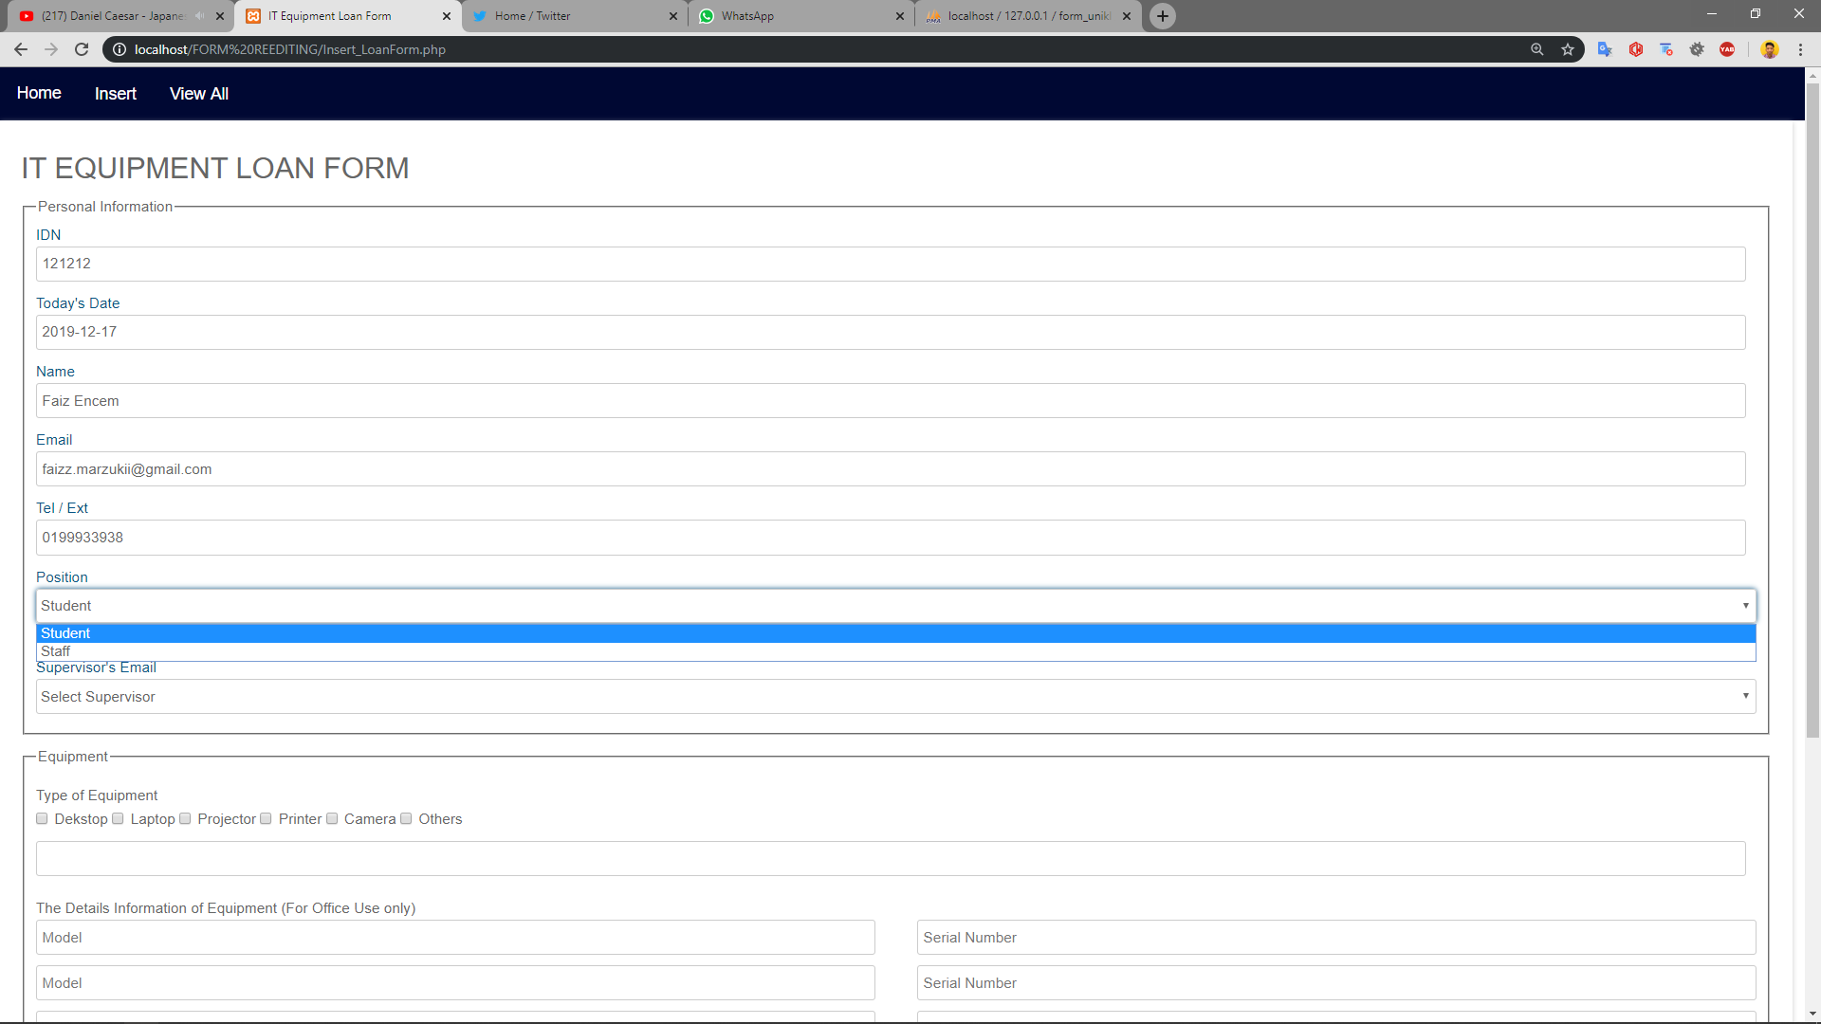

**4**

**3**

**2**

**1**

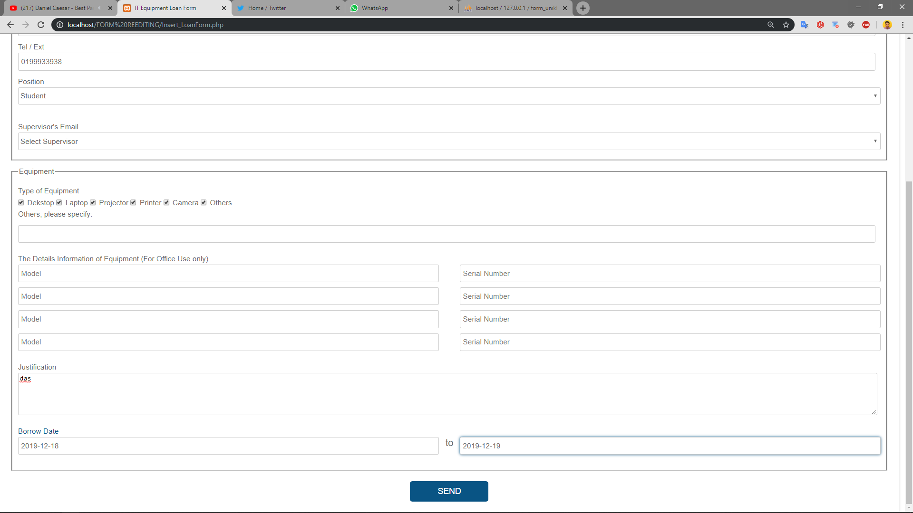

**5**

**6**

**7**

**8**

**9**

1. User need to enter their ID and the data of Name, Email, Phone Number will appear.

2. User need to insert today date.

3. User need to choose either they are Student or Staff.

4. Supervisor’s Email only available if user choose Student in step 3. They need to choose their supervisor for event.

5. User need to choose equipment that they want to loan from IT Unit.

6. If in step 5 user choose “Others” option, they need to fill this textarea with equipment that are not listed in the option.

7. User need to clarify their events name and location of their event here.

8. User need to enter date they want to loan the equipment.

9. User need to enter date they want to return the equipment.

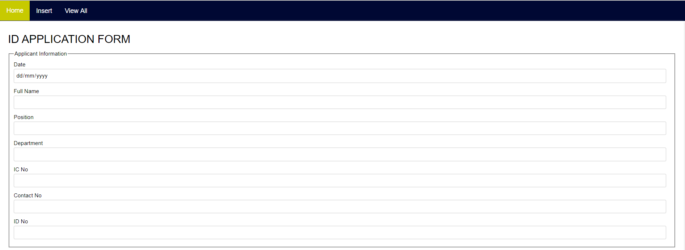

**1**

**2**

**3**

**4**

**5**

**6**

**7**

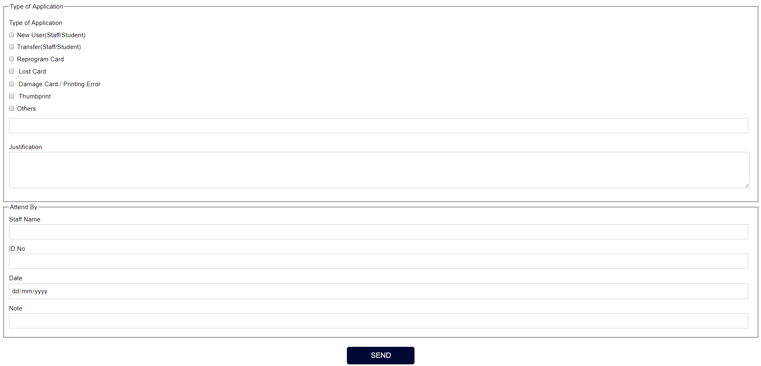

**10**

**9**

**8**

1. User need to insert application date.

2. User need to insert their name.

3. User need to fill their position either they are student or staff.

4. User need to fill their department name.

5. User need to fill their IC number.

6. User need to to fill contact number.

7. User need to fill ID number.

8. User need to choose type of ID Application.

9. If user choose others in option on step 7, they need to clarify it in textarea.

10. User need to justify why they want to create an ID card.

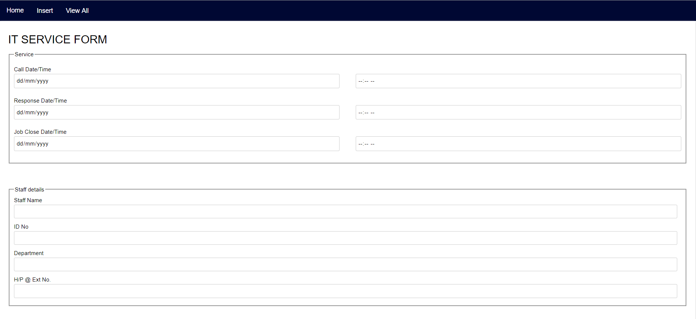

**2**

**1**

**3**

**4**

**5**

**6**

**7**

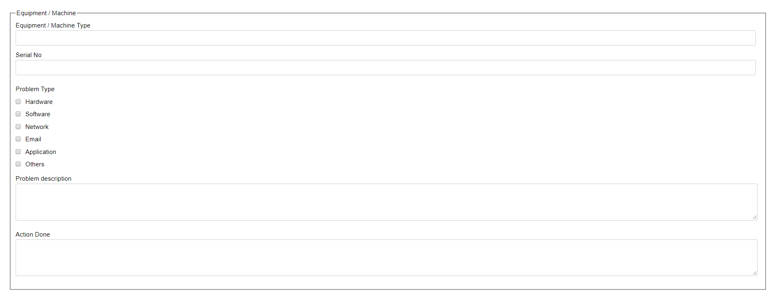

**8**

**9**

**10**

**11**

1. User need to insert Call Date and Time.

2. User need to insert Response Date and Time.

3. User need to insert Job Close Date and Time.

4. User need to insert staff name.

5. User need to insert staff ID.

6. User need to insert their department name.

7. User need to insert contact number.

8. User need to fill up name of equipment that need to be services.

9. User need to insert serial number of equipment that are going to be service.

10. User need to choose problem type.

11. User need to clarify the problem in detail.